Чиллаки навига берилган код
A₄-BARS181_187, C₁-WMC522_274, C₈-WMC522_195, D₁-WMC407_163, D₆-WMC407_117, E₃-WMC453_183, E₅- WMC453_168, G₃-WMS495_167, G₄-WMS495_159, H₁-CFA2201_ 208, H₃-CFA2201_171, I₁-CFD76 176, I₃-CFD76_125, J₁-WMC367_156, K₂-WMS11_212, M₁-WMS443_153, N₂-WMS291_115, O₂-CFA220_272, O₅-CFA220_215, Q₃-WMC74_253, R₃-WMS349_269, S₃-WMS301_234, T₄-WMC397_159, T₅-WMC397_133,Y₂-WMS261_185, V₁-GPW2181_270, V₂-GPW2181_200, V₃-GPW2181_154

Аллеллар сони, полиморфизм ахборот таркиби (PIC), (НЕ) гетерозиготалик (PIC га асосан танлаб олинган) ва NE (самарали аллеллар сони)
№ | Маркер номи | Аллеллар сони | Аллел ўлчами | PIC | HЕ | NE | Ишчи ҳарорат (0C) | Хромасомадаги ўрни
1 | BARS181 | 9 | 155-286 | 0,85 | 0,86 | 7,1 | 62,40 | 1B,7B
2 | WMC44 | 9 | 134-216 | 0,83 | 0,847 | 6,5 | 68,15 | 1B
3 | WMC522 | 12 | 102-94 | 0,83 | 0,846 | 6,5 | 57,16 | 2A,3D
4 | WMC407 | 7 | 223-78 | 0,82 | 0,838 | 6,2 | 65,87 | 2A
5 | WMC453 | 7 | 148-206 | 0,81 | 0,835 | 6,1 | 54,14 | 2A
6 | WMS294 | 7 | 168-196 | 0,78 | 0,807 | 5,2 | 66,29 | 2A
7 | WMS495 | 6 | 155-181 | 0,78 | 0,797 | 4,9 | 66,75 | 4B
8 | CFA2201 | 4 | 161-208 | 0,71 | 0,75 | 4 | 67,15 | 2B
9 | CFD76 | 4 | 114-176 | 0,69 | 0,747 | 4 | 66,62 | 6D
10 | WMC367 | 5 | 188-216 | 0,69 | 0,746 | 3,9 | 68,16 | 6B
11 | WMS11 | 6 | 166-188 | 0,71 | 0,745 | 3,9 | 64,52 | 1A,1B
12 | WMC314 | 6 | 150-200 | 0,62 | 0,724 | 3,6 | 67,07 | 2B
13 | WMS443 | 4 | 166-253 | 0,68 | 0,717 | 3,5 | 46,84 | 5A,5B
14 | WMS291 | 5 | 153-319 | 0,63 | 0,7 | 3,3 | 53,97 | 5A
15 | CFA220 | 7 | 186-227 | 0,54 | 0,695 | 3,3 | 58,36 | 2A,2B
16 | BARC1138 | 4 | 145-172 | 0,65 | 0,694 | 3,3 | 59,66 | 2D
17 | WMC74 | 4 | 237-275 | 0,61 | 0,687 | 3,2 | 62,4 | 4D
18 | WMS349 | 4 | 108-274 | 0,54 | 0,687 | 3,2 | 66,92 | 2D
19 | WMS301 | 4 | 209-277 | 0,66 | 0,681 | 3,1 | 55,6 | 2D
20 | WMC397 | 6 | 126-190 | 0,64 | 0,681 | 3,1 | 64,52 | 6B,7B
21 | WMS261 | 4 | 184-215 | 0,59 | 0,678 | 3,1 | 68,96 | 2D
22 | GPW2181 | 3 | 154-270 | 0,58 | 0,662 | 3 | 66,35 | 5A,6A

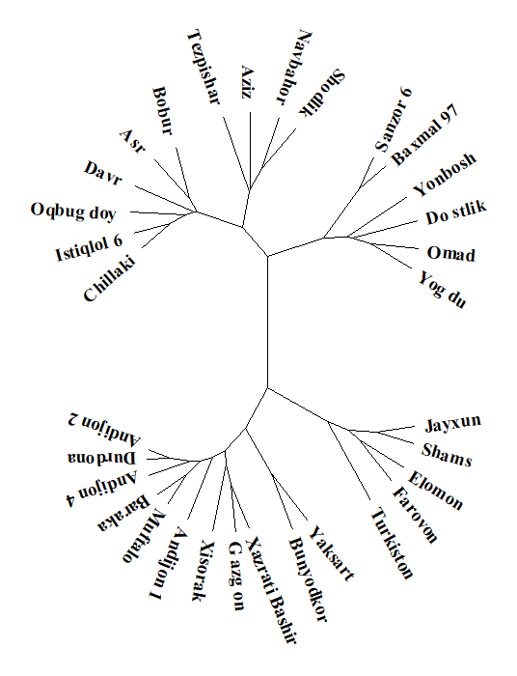
1-расм. Маҳаллий буғдой навларининг SSR-маркерлар бўйича “илдизга” (root) эга бўлган филогенетик дарахти

